Exploratory Analysis of Undergraduate Enrollment
at Institutions Comparable to Elmhurst University

Ionela Borozan, Tanja Gllafce, and Weronika Papp

Elmhurst University
BUS-320: Survey of Business Analytics
Dr. Avraham Baranes
December 9, 2025

Executive summary
This project analyzed data from institutions comparable to Elmhurst University to understand factors influencing undergraduate enrollment. The analysis focused on trends in enrollment, retention, graduation, financial aid, tuition, and other institutional characteristics and included years 2019-2022.
Elmhurst performs very well in retention, graduation rates, and enrollment compared to similar institutions. Students receive more financial aid than average, which helps support their success. However, lower admission yields and higher tuition may make it harder to attract new students. These results suggest that Elmhurst supports students effectively once they are enrolled, but recruitment and cost factors could be improved. Future studies with more complete data and consistent reporting will help the Board of Trustees make better decisions and track performance over time.
Introduction
The purpose of this project was to analyze data to identify different reasons that can influence undergraduate enrollment at institutions comparable to Elmhurst University. The goal of the analysis was to explore how these characteristics relate to enrollment levels and to identify trends over time that may offer insight into broader patterns within this group of institutions. This analysis was requested by the Elmhurst University Board of Trustees, who plan to use the results to inform strategies for strengthening undergraduate enrollment.

Methodology
The cleaned dataset was imported into a data visualization software, where a series of visuals were created to examine undergraduate enrollment, financial characteristics, institutional context, and student outcomes. These visuals included: undergraduate enrollment rankings, admission and yield rates, tuition and fee comparisons, financial aid variables, housing charges, urbanization level, NCAA membership, and retention and graduation rates by institution size. Several of these visuals required the creation of custom measures, including ranking functions to display the top five institutions for each metric while always including Elmhurst University for comparison. This was a necessary precaution as the purpose of this analysis was to see how Elmhurst University ranks amongst the strongest universities. Additional calculations were used to convert raw numeric variables into percentages, and calculated tables were created when variables needed to be grouped (such as institution size categories). Filters and hierarchies were applied to ensure consistency across the dashboards.
This structure allowed the analysis to focus on how institutional characteristics varied across universities in the sample and how Elmhurst compared its peers each year. However, because the dataset was unbalanced, year-to-year comparisons within the data visualization tool could not be made directly using the same institutions for every metric. To explore overall trends across the four-year period, averages were calculated for the key variables such as enrollment, admission yield, financial aid, tuition, net price after financial aid, retention, and graduation rates to summarize changes over time. Using averages rather than institution-level panel data ensured that trends could be evaluated even when some universities were missing data for one or more years.
This combined approach with visual and year-specific analysis in the data visualization tool and trend analysis provided a structured and reliable methodological framework for examining institutional characteristics over the 2019–2022 period without introducing inconsistencies caused by missing or incomplete observations.
Results
Using the cleaned and structured dataset, we examined key indicators of undergraduate enrollment, student success, and financial characteristics across institutions similar to Elmhurst University. By comparing Elmhurst to similar institutions, we were able to identify strengths, challenges, and patterns that may inform Elmhurst University on how to increase recruitment and student success. The following sections summarize these trends and highlight how Elmhurst’s performance compares to similar schools. The results show important differences between Elmhurst University and similar institutions that could influence future decisions and outcomes.
In 2019, Elmhurst University tended to rank below the top institutions in undergraduate enrollment, with an enrollment of roughly 2.9 thousand students compared to 4.6–6.4 thousand students at similar universities. Admissions data showed that Elmhurst had a moderate admission rate (68%), but a comparatively low yield rate (18%), meaning fewer admitted students chose to enroll relative to peer institutions. In terms of cost, Elmhurst’s tuition and fees ($38,000) were substantially lower than those of the highest-priced colleges in the sample, which ranged from $54,000 to $59,000. However, Elmhurst also awarded lower levels of institutional, federal, state ($25,000), and Pell Grant aid ($4,000) compared to the top-aid-providing institutions, suggesting that lower tuition usually correlates with lower aid packages.
The 2019 demographic and contextual visuals in the data visualization tool offered additional insight into Elmhurst’s position among peer institutions. Institutions located in cities accounted for the largest share of undergraduate enrollment in the dataset (41.28%), followed by those in towns (31.43%), suburbs (22.97%), and rural areas (4.33%). NCAA membership was also prominent, with nearly two-thirds of institutions identified as NCAA schools. When examining student outcomes by institutional size, larger universities showed higher retention and graduation rates, a pattern that was held when comparing Elmhurst to institutions within similar size categories. Elmhurst University performed at the upper end of its size category with an average retention rate of 80% (compared to 76% in its size category) and an average graduation rate of 68% (compared to 62% in its size category). Elmhurst’s housing charges ($6,200 for room charges and $4,300 for board charges) were also lower than those of the top-cost institutions, which had room and board totals exceeding $14,000 annually.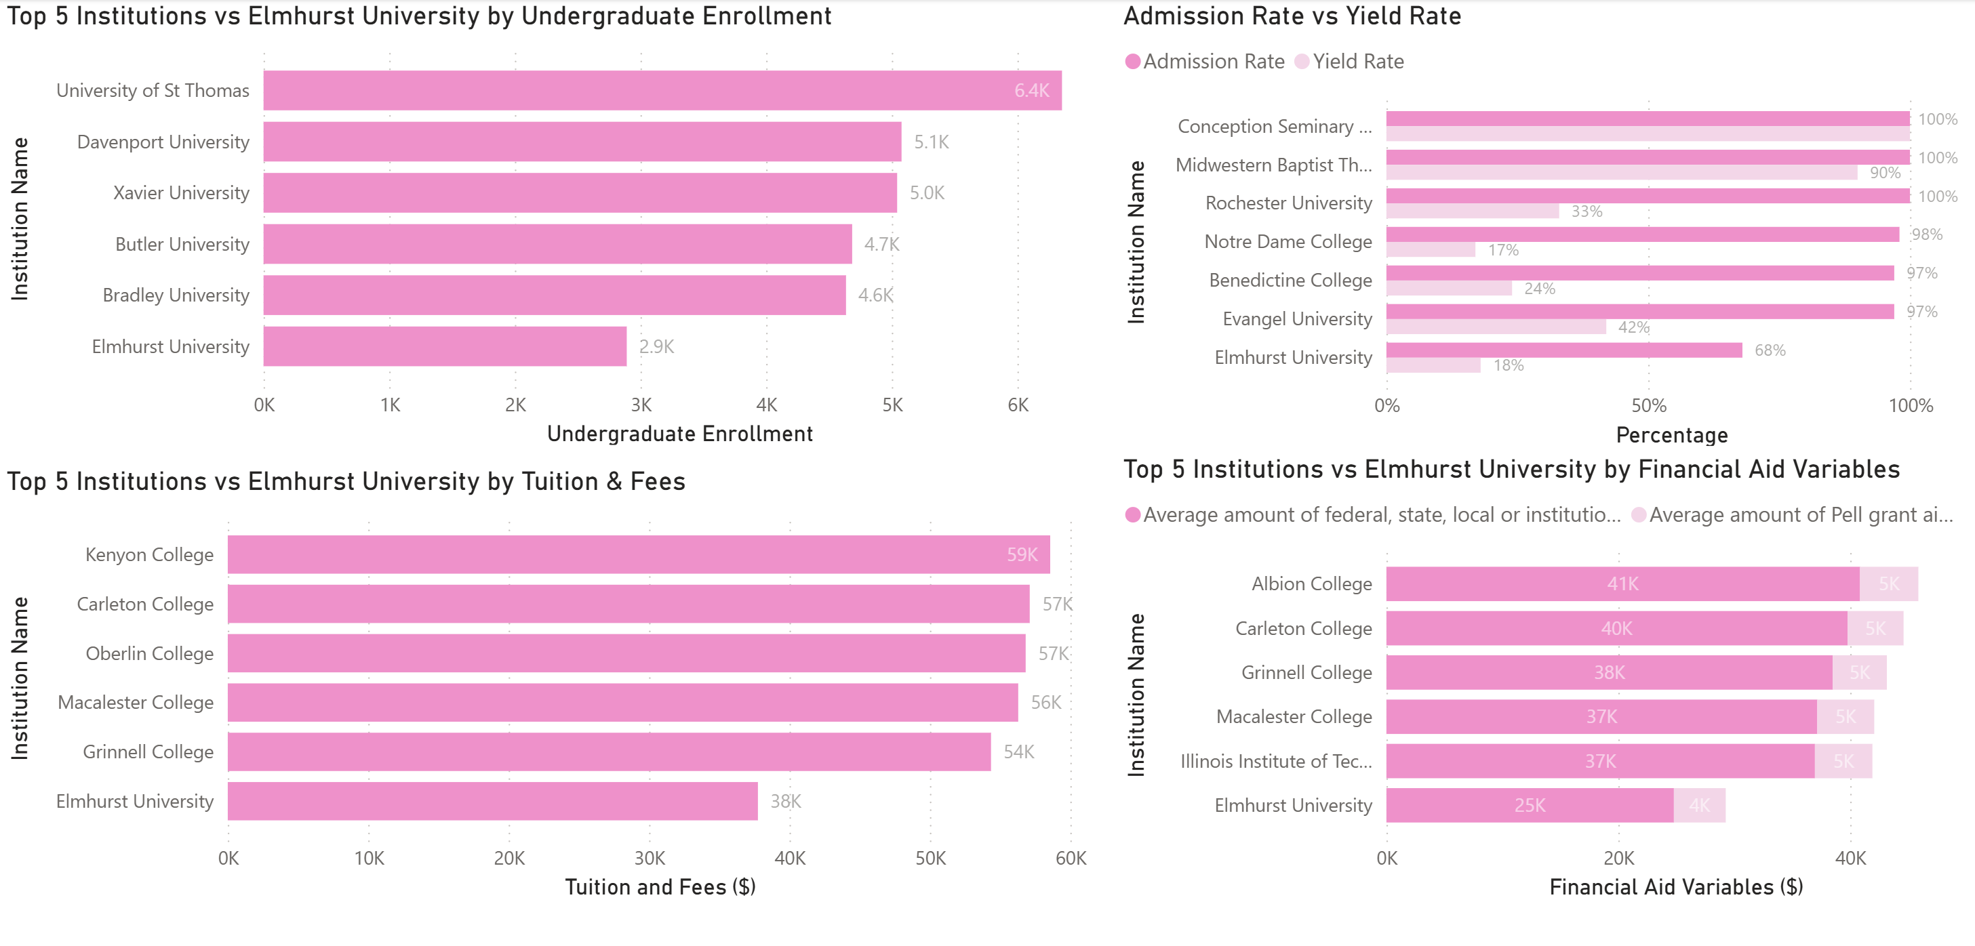

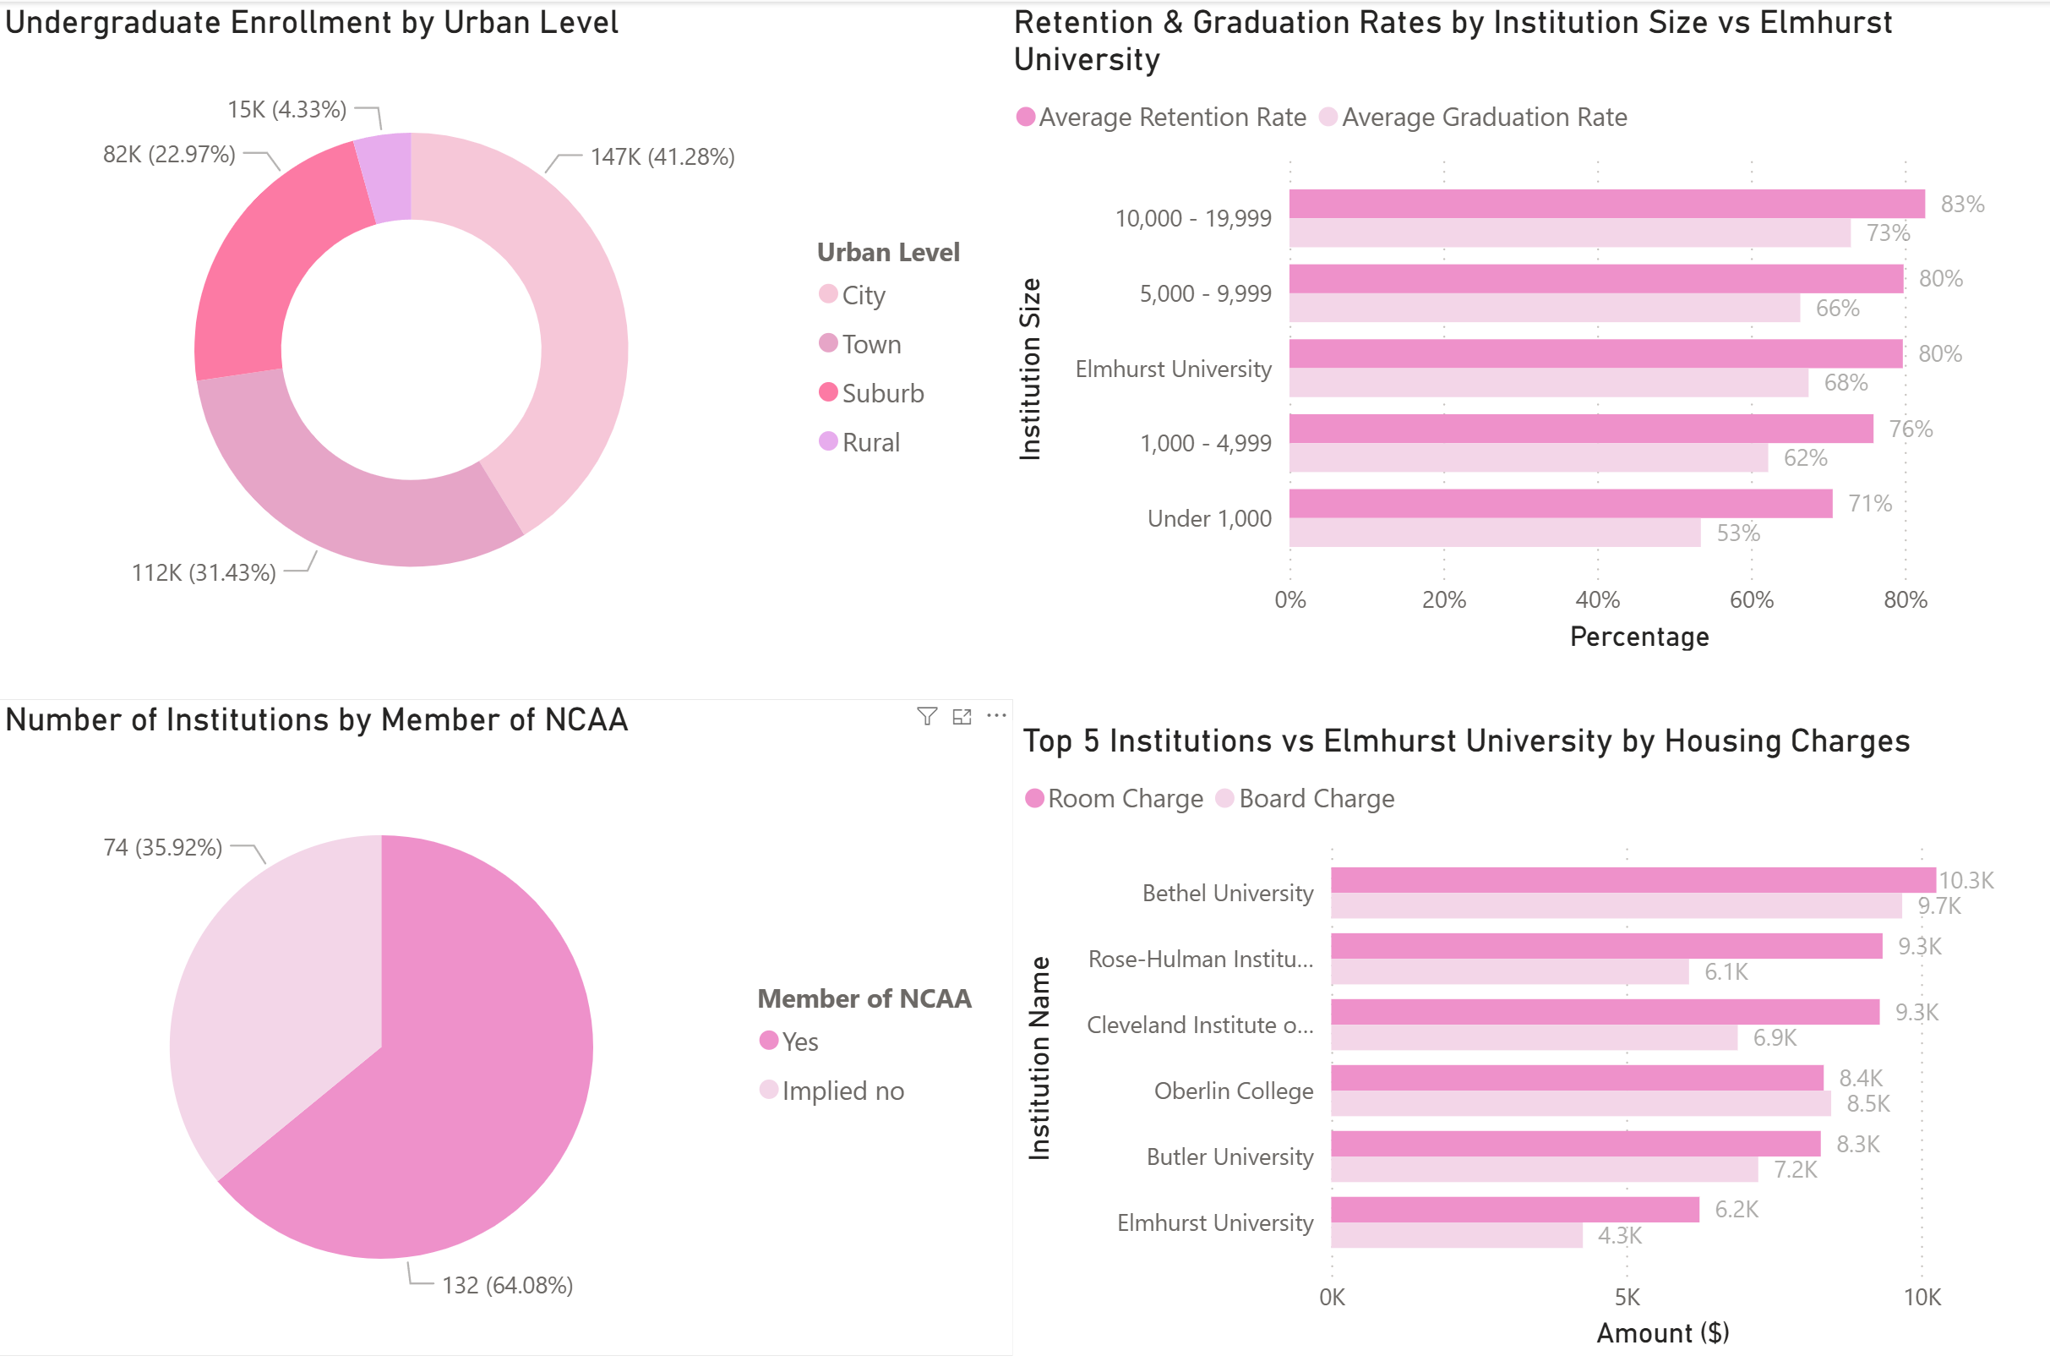

In terms of overall performance, Elmhurst University shows a mix of strengths and challenges compared to similar institutions. Its admissions yield is lower than the average every year and fluctuates more, with a particularly sharp drop in 2022 (Figure 1). This indicates that while Elmhurst University admits students, fewer of them choose to enroll compared to peer institutions. Tuition might be a contributing factor, as Elmhurst charges more than the average and rises steadily each year. On the other hand, average tuition across comparable institutions shows a sharp increase after 2021, while Elmhurst’s tuition continues its steady upward trend (Figure 6).
At the same time, Elmhurst consistently provides more financial aid than the average school, with aid amounts increasing over time (Figure 2). This suggests that financial aid may be used strategically to attract students. Enrollment remains higher than average and stable, even increasing in 2022, while peer institutions experience slight declines (Figure 3). Graduation and retention rates are also above average. Graduation rates show a slow decline over time, while the average remains relatively flat (Figure 4). Retention rates are generally strong but experienced a noticeable dip in 2021 before recovering in 2022 (Figure 5). Figures referenced in this section (Figures 1–6) are presented on the following pages for review.
Figure 7 shows the net price for Elmhurst University compared to the average institution from 2019 to 2022. Net prices at Elmhurst increase each year, with a noticeable rise in 2021. When this is compared with Figure 5 (Retention Rate), we see that retention drops for Elmhurst in the same year. In addition, Figure 2 shows that financial aid increased, but it did not fully balance the rise in net price. This pattern may suggest a possible relationship between higher student costs and the decline in retention. This trend should be examined further to prevent future retention problems and to determine whether changes in tuition or net price directly affect students’ decisions to stay enrolled.

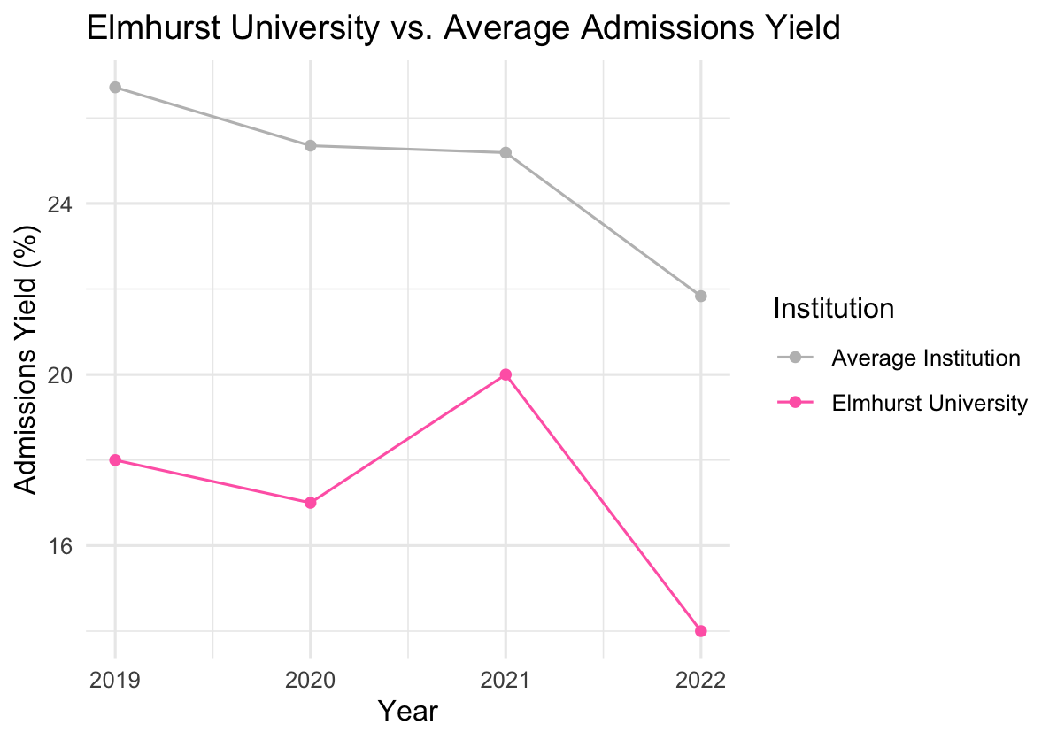Figure 1. Admissions Yield (%) for Elmhurst University vs. Average (2019–2022)
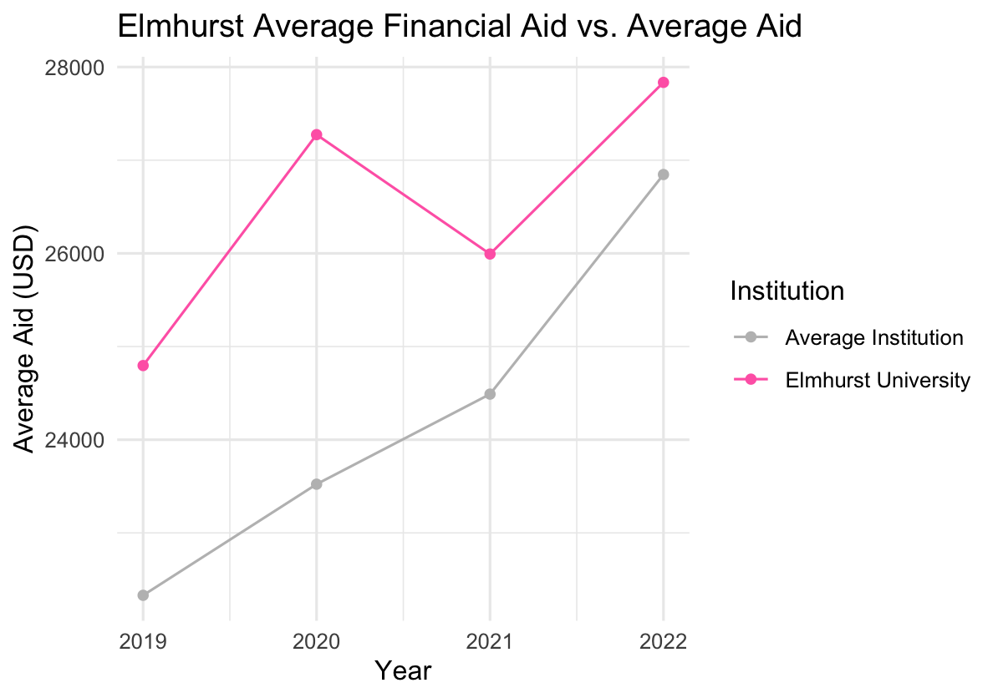Figure 2. Average Financial Aid ($) for Elmhurst University vs. Average (2019–2022)

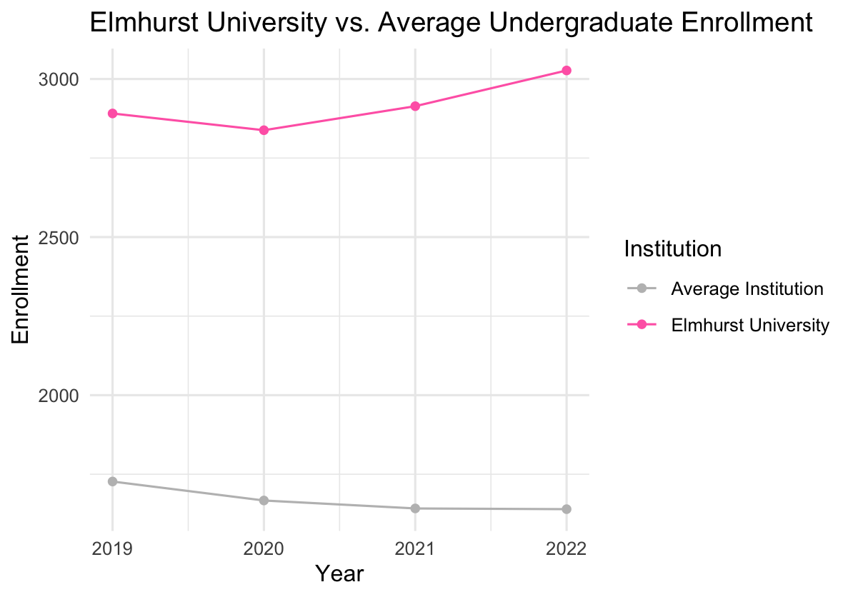 Figure 3. Enrollment Levels for Elmhurst University vs. Average (2019–2022)
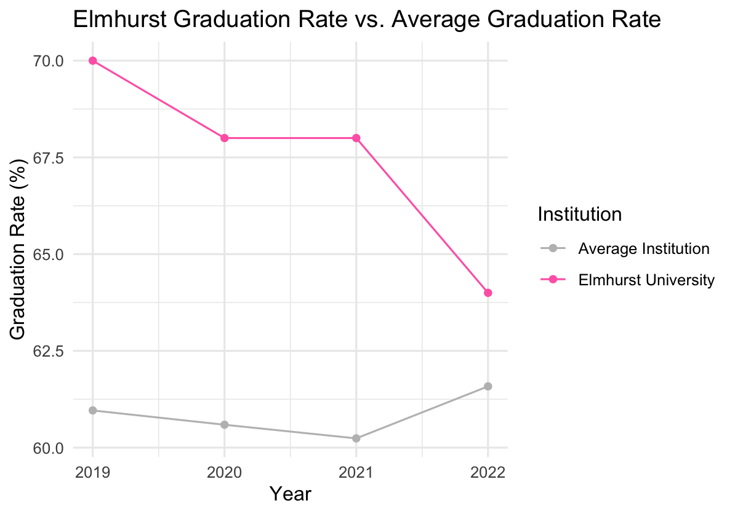Figure 4. Graduation Rate (%) for Elmhurst University vs. Average (2019–2022)
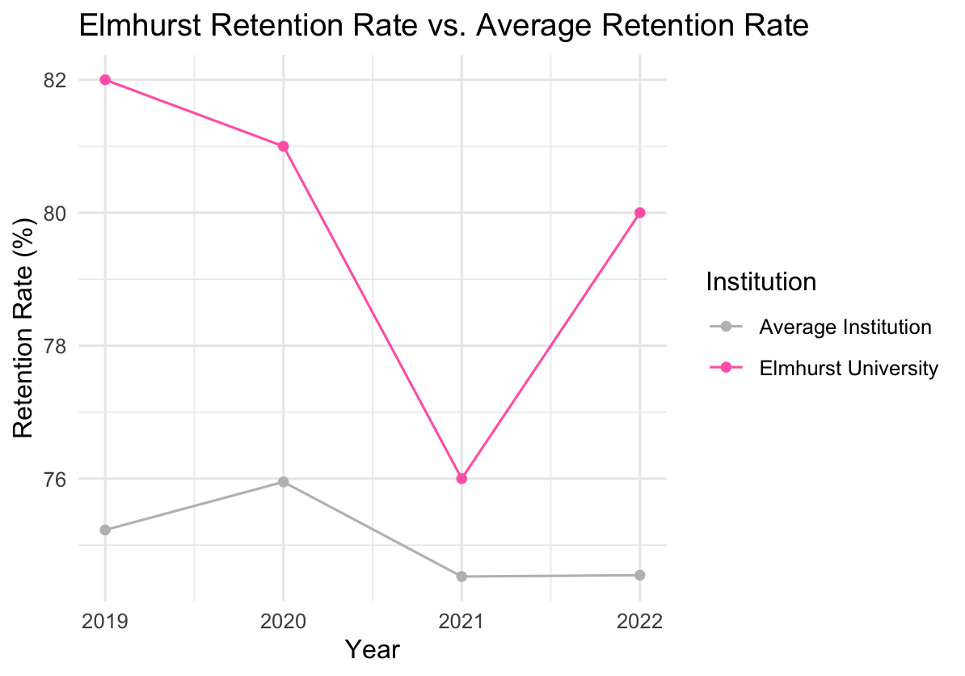Figure 5. Retention Rate (%) for Elmhurst University vs. Average (2019–2022)
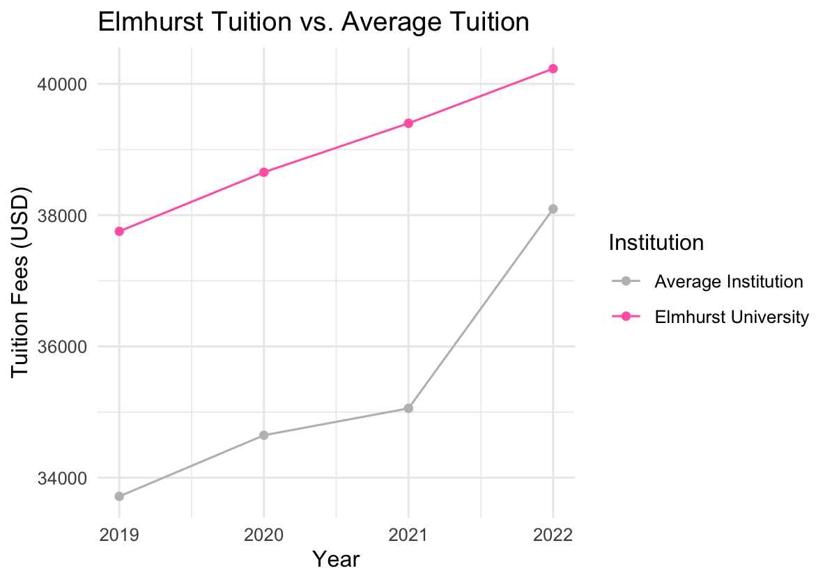Figure 6. Tuition ($) for Elmhurst University vs. Average (2019–2022)

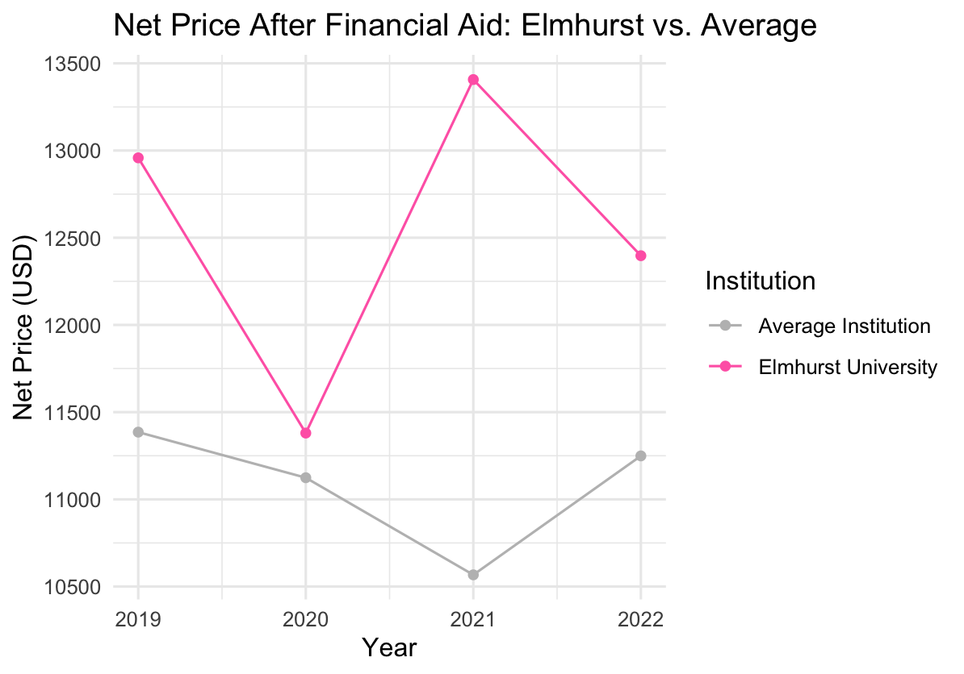Figure 7. Net price ($) for Elmhurst University vs. Average (2019-2022)

Elmhurst outperforms average institutions in retention, graduation, enrollment, and financial aid, but it underperforms admissions yield and faces higher tuition costs. These findings suggest that Elmhurst University students receive very strong academic outcomes and student support; however, high costs might make it more challenging to attract new students. Together, these findings show that Elmhurst has strong student outcomes, even though some financial and recruitment factors may limit enrollment growth.
Looking at the bigger picture, these results offer a focused view of how financial, academic, and institutional characteristics relate to enrollment at institutions like Elmhurst, but they do not capture every possible factor that may influence student decisions or affect other types of universities. One limitation of this project is that the dataset is unbalanced, with some schools missing information for certain years after cleaning. Because of this, it was not possible to directly compare Elmhurst to specific schools of interest over time. A balanced dataset would make this easier, as each school would have the same years of data. In the future, using a smaller but balanced dataset could allow for more direct comparisons and a better understanding of how Elmhurst performs relative to specific institutions, not just the average. Future research that includes more years of data, additional institutional characteristics, and qualitative information about student decision-making would also provide a more complete understanding of how enrollment patterns evolve over time.
Given these limitations and opportunities for further study, the visualizations developed for this project provide the Board with a flexible tool to explore the data in more detail. Using the filters organized by institution, year, and variable type, the Elmhurst University Board of Trustees can examine specific aspects of interest, such as changes in tuition, fluctuations in retention and graduation rates, or differences in financial aid across schools. These tools allow for deeper, institution-specific comparisons, complementing the broader trends identified in this analysis.
Finally, this project highlights the importance of data governance for institutional decision-making. As described in the methodology, some observations were missing or excluded due to incomplete information, and certain variables showed inconsistencies across years and schools. These issues created an unbalanced dataset and limited the ability to make direct comparisons between Elmhurst and specific peer institutions. Strong data governance, including standardized reporting, regular updates, and validation of variables, would help to ensure that future studies are more reliable. Improved data quality would allow the Board to make better data-driven decisions and allow comparisons that track Elmhurst’s performance relative to individual schools over time.
Conclusions
Elmhurst University performs very well in retention, graduation rates, and enrollment when compared to similar institutions. Students receive more financial aid than average, which helps to support their success. However, Elmhurst has lower admissions yield and higher tuition rates, which may make it difficult to attract more students to enroll after being admitted. Elmhurst University helps students succeed once they are enrolled, which is supported by higher graduation rates. Future studies with more complete data and additional years could give a better understanding of how these factors influence student decisions. Improving data quality and consistency will help the Board of Trustees make better decisions and track performance over the years to mitigate any problems.

Appendix A. Data Availability Statement
The dataset used in this study was sourced from publicly available IPEDS data, which can be accessed at: https://nces.ed.gov/ipeds/use-the-data. The cleaned dataset can be provided by the authors upon request.

